INDUSTRY PROJECT: PROJECT REPORT
Industry Project title | Superstore Profit Analysis
Name of the Company | TCS
Name of the Institute | JNTUH College Of Engineering Manthani
Start Date | End Date | Total Effort(hrs) | Project Environment | Tools Used
Sep 28th 2025 | Nov 8th 2025 | 90 | Windows OS, Jupyter Notebook, MySQL, Power BI | Python(Pandas, Matplotlib, Seaborn), MySQL,Tableau, Jupyter notebook

Acknowledgement
I would like to express my heartfelt gratitude to my mentors at TCS, my faculty guide, and the management of JNTUH University College of Engineering Manthani for providing continuous guidance throughout this project. Their support helped me gain exposure to real-time data analysis, business intelligence, and visualization techniques required for industry projects.

Abstract
This project focuses on performing end-to-end analysis on the Superstore sales dataset to identify the key drivers of sales performance and profitability. Using Python for data cleaning and exploratory data analysis (EDA), and Tableau for dashboard creation, the project uncovers insights into customer behavior, sales trends, category performance, discount impact, and geographical profitability. The methodology includes data preprocessing, feature engineering, univariate and multivariate analyses, time-series exploration, and interactive dashboard creation. The results of the analysis enable strong business recommendations that can help improve marketing strategies, inventory planning, and operational decisions.

Introduction
In retail analytics, understanding what drives profit and loss is crucial for decision-making. This project analyzes Superstore sales data to extract meaningful business insights. Key terms include: Sales (revenue), Profit (net gain), Discount (price reduction), Category (product group), Segment (customer type), and Region (geographical classification). The project follows a full data science workflow, integrating multiple analytical techniques with visualization tools to bring clarity to complex business patterns.

Objective and Scope
The main objective is to analyze historical Superstore data to identify the factors influencing revenue and profitability. Scope includes: data cleaning, preprocessing, feature engineering, exploratory data analysis, geospatial and time-series analysis, interactive Tableau dashboard, and business insights. The project is restricted to the given dataset and focuses on analytical interpretation rather than predictive modeling.

Problem Statement
Retail companies often struggle to identify where profits originate, which categories cause losses, and how discounts influence revenue. This project addresses these problems by analyzing regional performance, category trends, discount behavior, shipping times, and customer segmentation patterns to support data-driven decision-making.

Existing Approaches
Traditional reporting methods provide only basic sales summaries without deep analytical insights. This project enhances existing approaches by integrating visual analytics, profit margin interpretation, geospatial mapping, and customer-level segmentation to deliver a complete analytical view.
Approach / Methodology
The methodology followed for this project includes the following phases:
1. Data Collection: Used the Sample Superstore dataset (CSV).
2. Data Cleaning: Handled missing values, corrected datatypes, removed duplicates.
3. Feature Engineering: Created derived fields such as Profit Margin, Order Year, and Discount Range.
4. Exploratory Data Analysis: Performed statistical and visual analysis using Python (Pandas, Matplotlib, Seaborn).
5. Dashboarding: Built an interactive Tableau dashboard for visualization and exploration.
6. Insight Generation: Interpreted analytical results and proposed business recommendations.
Tools and Technologies Used
• Python (Pandas, NumPy, Matplotlib, Seaborn, Plotly) for data preparation and EDA
• Jupyter Notebook for implementation
• Tableau for interactive dashboard creation
• Dataset: Superstore Sales Data (9,900+ rows, 21 fields)
• Additional tools: SQL (verification), Excel (pre-checking)

Project Workflow

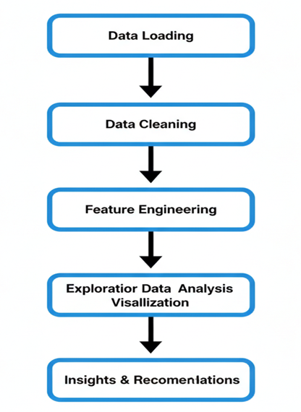

1.Problem understanding and requirement identification
2. Dataset loading and structure analysis
3. Data cleaning and missing value handling
4. Data type correction and transformation
5. Feature engineering: Profit Margin, Order Year, Order Month, Ship Duration
6. EDA: univariate, bivariate, multivariate, time-series, geographical
7. Tableau dashboard creation for interactive insights
8. Insight generation and business recommendations

Data Cleaning and Preprocessing
• Checked dataset structure and column types
• Converted date fields into datetime format
• Cleaned numeric columns by coercing incorrect values
• Removed duplicates to ensure accuracy
• Handled missing Ship Dates (accepted as realistic missing data)
• Ensured consistency across Category, Segment, State, and Region fields

Feature Engineering
• Order_Year: extracted year from Order Date
• Order_Month: extracted month number
• Month_Name: extracted month name for time-series visualizations
• Profit_Margin = Profit / Sales
• Ship_Duration = Ship Date – Order Date
• Categorical groupings for better Tableau filtering

Exploratory Data Analysis (Detailed)
Univariate Analysis: Sales and Profit distributions show high variation; some products generate negative profit.
Bivariate Analysis: Category vs Profit shows Technology performing best; Furniture contributing losses.
Multivariate Analysis: Discounts above 30% drastically reduce profitability.
Time-Series Analysis: Sales peak in November–December; lowest in February.
Geospatial Analysis: West region shows highest profit; some states show continuous losses.
Segment Analysis: Corporate segment contributes highest profit margin.

Results and Interpretation
The analysis reveals that Technology category and Corporate customer segment drive major profit. Furniture category suffers due to high discounting and shipping delays. Profitability varies significantly across states. Time-series patterns indicate seasonal demand in the last quarter of the year. Discounts play a critical role in reducing profit margins, highlighting the need for a refined discount strategy.

Tableau Dashboard Summary
The dashboard includes:
• State-wise profit map
• Sales vs Profit trend line (2014–2017)
• Category-wise profit comparison
• Segment-level profit visualization
• Discount vs Profit scatter plot
• KPI cards showing Total Sales, Total Profit, Average Discount
Interactive filters: Region, Category, Segment, Year.
Visual output
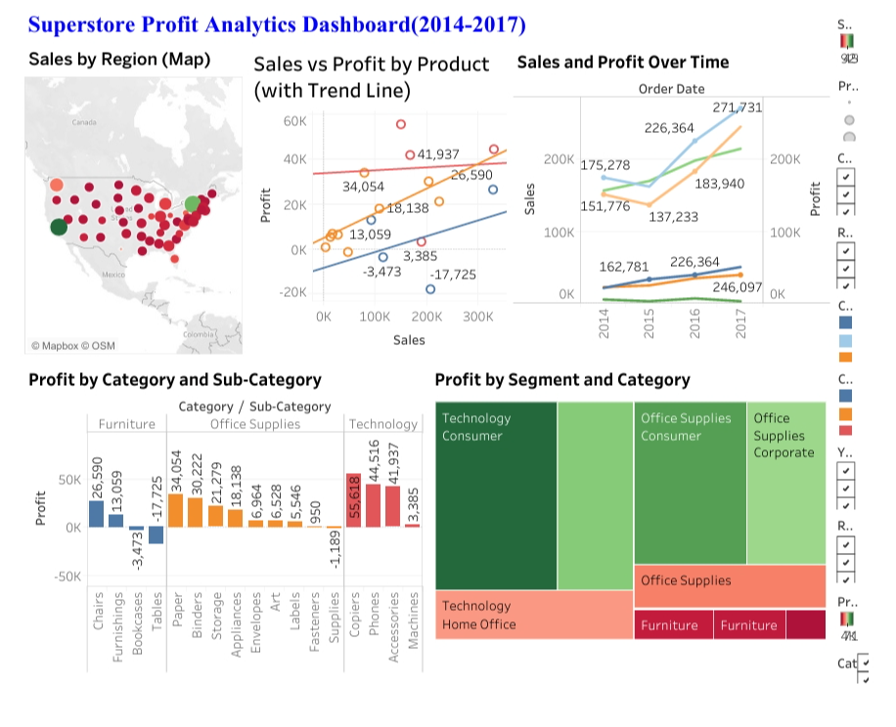
Assumptions
• The dataset accurately represents the sales transactions for the Superstore business.
• No significant data entry errors exist beyond those handled during preprocessing.
• Discounts, profit, and sales values are correctly recorded and representative of business operations.
Implementation
Implementation was carried out in Python using Jupyter Notebook. Data preprocessing, cleaning, and feature creation were performed using Pandas and NumPy. Exploratory Data Analysis (EDA) was done using Seaborn and Matplotlib for visualization. Tableau Desktop was used to design an interactive dashboard for exploring key KPIs such as Sales, Profit, and Profit Margin across different categories, regions, and time periods.
Solution Design
The solution integrates data preprocessing and analysis in Python with visualization in Tableau. The system design includes the following components:
1. Data Ingestion: Reading raw CSV data.
2. Data Processing: Cleaning, transformation, and feature engineering.
3. Analytical Modeling: Generating summary statistics and visual trends.
4. Visualization Layer: Tableau dashboard with filters and KPIs.
Challenges
• Missing ship dates required assumption handling
• Negative profits needed careful interpretation
• High variability in discount patterns required deeper analysis

Opportunities
• Improve inventory planning in high-demand months
• Optimize discounting policies to prevent losses
• Focus marketing efforts on high-profit regions

Recommendations
1. Reduce discounts above 30% to prevent negative profitability.
2. Improve shipping processes for Furniture category to reduce losses.
3. Increase promotional activities in profitable states such as those in the West region.
4. Strengthen customer loyalty programs for Corporate segment.
5. Increase inventory stock during high-demand months like November and December.

Conclusion
The project successfully delivers a complete analysis pipeline from dataset exploration to dashboard creation. The insights uncovered support business decisions for improving marketing, discounting, logistics, and inventory strategies. Integrating Python with Tableau ensures both depth of analysis and user-friendly visualization for management review.

Future Enhancements
• Build predictive models (Sales Forecasting / Profit Prediction)
• Deploy dashboard on Tableau Server or Power BI Service
• Automate ETL pipeline
• Add regional demographic data for advanced insights

References
- Kaggle Superstore Dataset
- Python Official Documentation
- Tableau Knowledge Base
- Data Visualization Standards

